**PARALLEL AND DISTRIBUTED PROCESSING  
PROGRAMMING ASSIGNMENT**

**Exercise 1:**

***PROBLEM STATEMENT***:

Implementation of the sorting algorithm for an arbitrary number of processes using MPI send/receive.

***SOLUTION APPROACH:***

Steps followed for approaching the solution:

* Initially we are provided the program that can sort only by 2 processes using MPI send/receive. Now we need to implement the program that works for multiple processes more than 2 using MPI send/receive.
* Firstly we need to find the remainder by dividing the input array size with the processes entered so that we can find out how many extra data elements will be there after equal data distribution.
* This will be done by. Int rem = No_of_Elements % arr_size
* Here the program divides the array among the number of processes entered using MPI send. So each processor sorts the input separately and at last combines them using MPI receive.
* Data from processors considered will be in sorted order but when collected by the root processor it will be not in sorted order.
* At the root process whole array is again sorted using the merge method in the program.
* Hence here we use the **MPI_Send** for sending the appropriate data portion to the processors and **MPI_Receive** for combining the numbers that are sorted by different processes separately.
* Below figure shows how it works for when we take 2 processes.

***Instructions for Running the program:***

COMPILE: mpicc -o sortSR sortSR.c

RUN : mpirun -n 2 ./sortSR

***ASSUMPTIONS:***

1. Maximum number of elements considered is 50.

***Fig:1*** Shows the demonstration for sorting by 2 processes

***Fig: 2*** Shows the demonstration for sorting by 3 processes

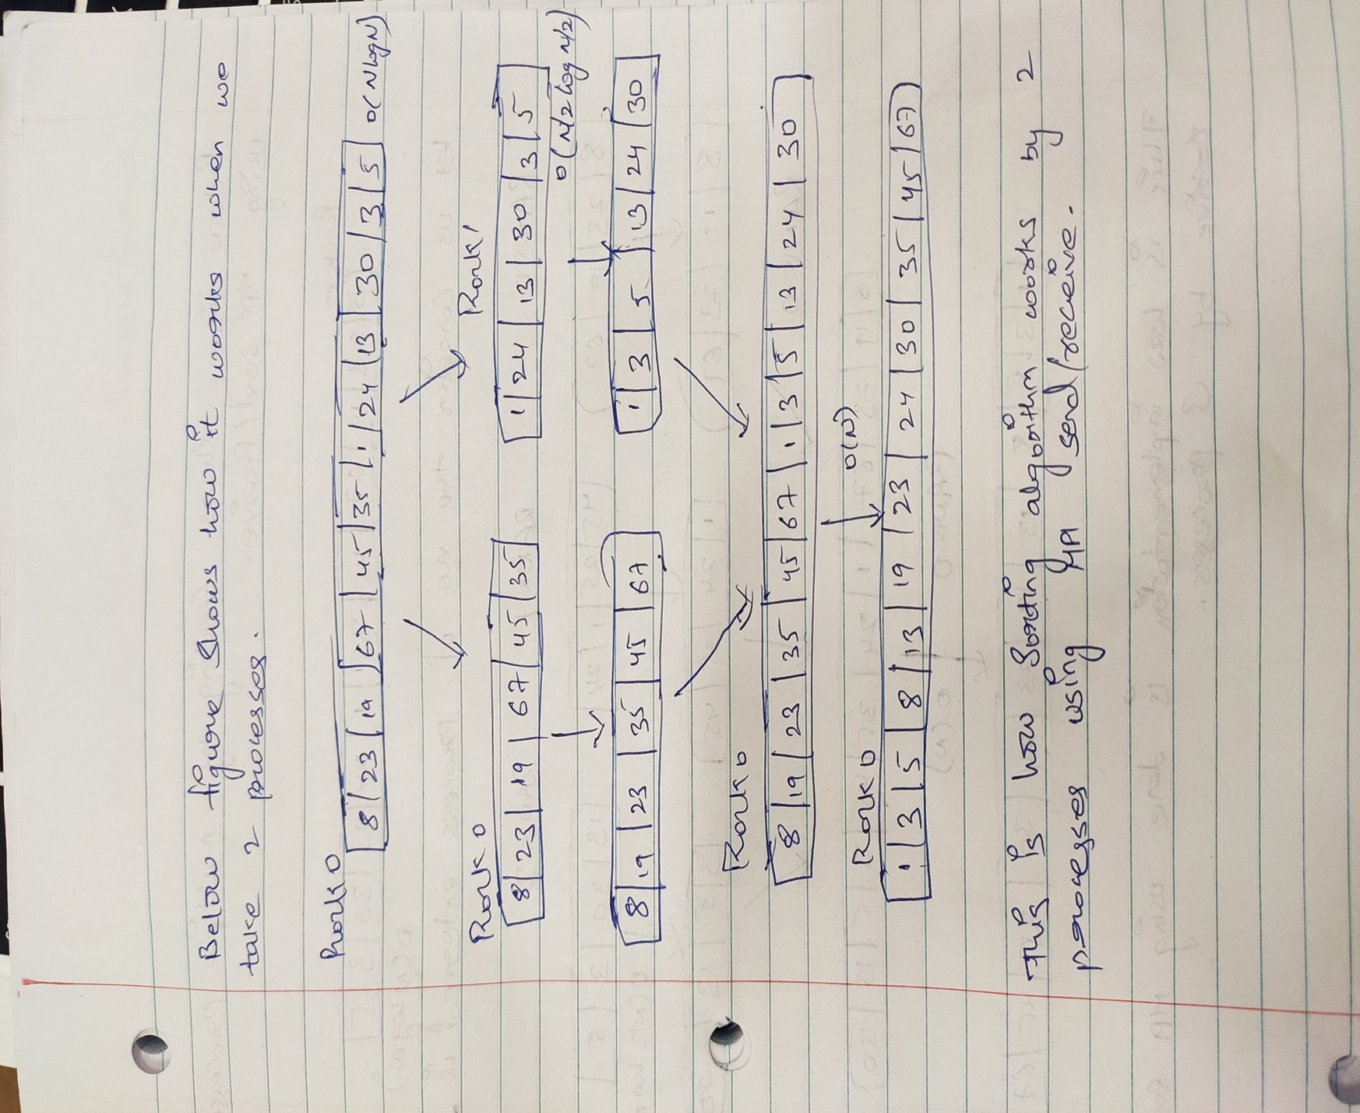

***Fig:1***

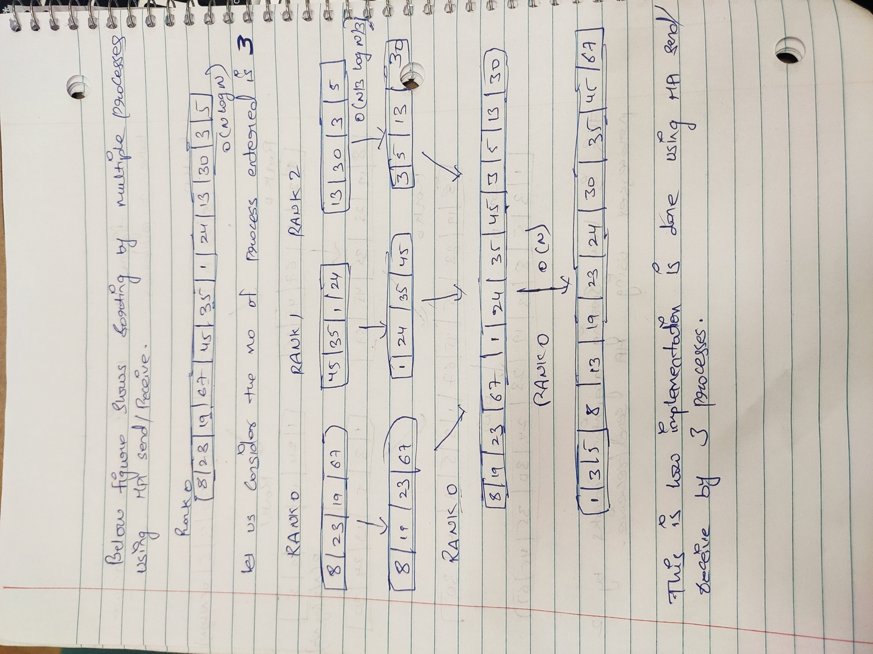

***Fig: 2***

***CODE:*** attached file ( sortSR.c)

***OUTPUT:***

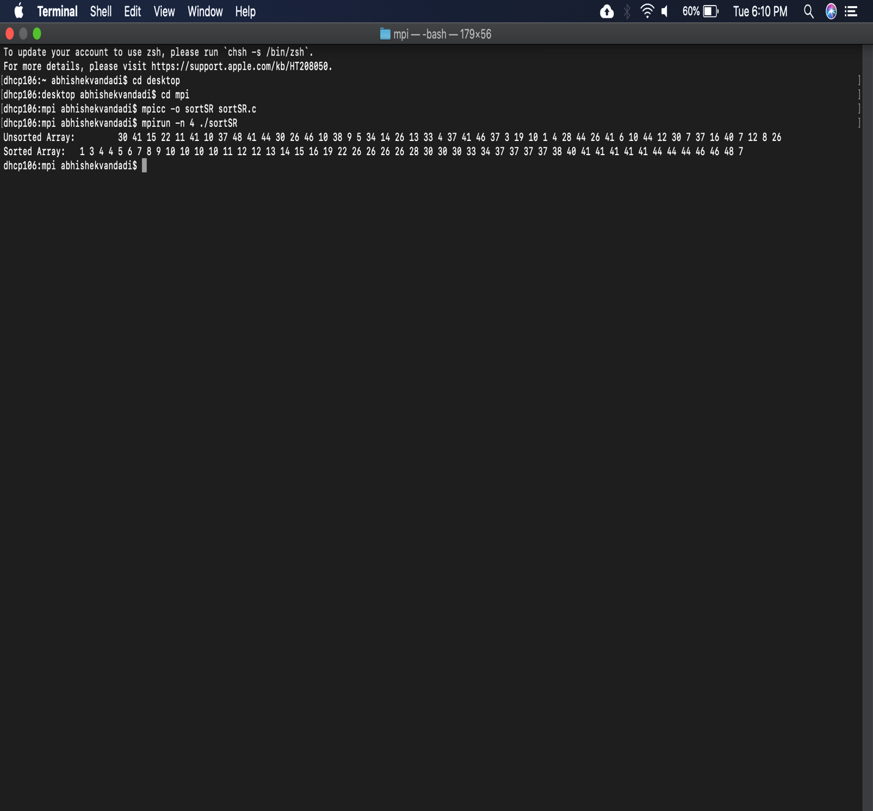

***Fig: 3***

***Performance analysis: ( Execution Time)***

The execution time for the following random data set is 0.000913.



**Exercise 2:**

***PROBLEM STATEMENT***:

Implementation of sorting algorithm using scattering and gathering collective APIs without using MPI send/receive.

***SOLUTION* APPROACH*:***

Steps followed for approaching the solution:

* Normally we were using MPI send/receive for sorting the algorithm, now we need to implement the algorithm using MPI Scatter/Gather.
* MPI scatter/ gather functionalities works as follows.
* Randomly input is taken and divided among process equally, here constraint is applicable that the entered processes number should equally divide the data.
* Now the input array data is divided among the processors equally using the MPI_Scatter and the sorting is done by individual processes seperatley.
* Atlast the MPI_Gather method is used to combine the separated input from all the processes.

***Instructions for Running the program:***

COMPILE: mpicc -o sortSG sortSG.c

RUN : mpirun -n 2 ./sortSG

***ASSUMPTIONS:***

1. Maximum number of elements considered is 20.

***Fig:1*** Shows the demonstration for sorting by 4 processes using Scatter and Gather methods.



***Fig: 1***

***CODE:*** attached file ( sortSG.c)

***OUTPUT:***

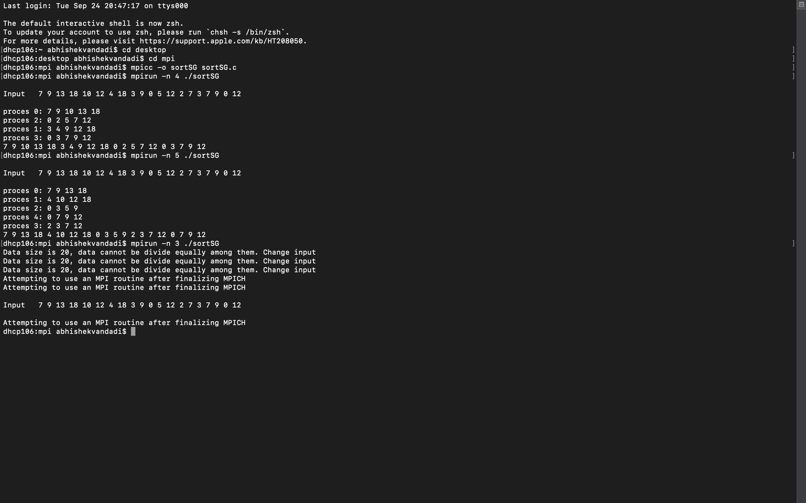

***Fig: 2***

**Exercise 3:**

***PROBLEM STATEMENT***:

Implementation of sorting algorithm using a single collective call (Alltoallv).

***SOLUTION* APPROACH*:***

Steps followed for approaching the solution:

* MPI_Isend and MPI_Irecv blocking calls are used in the given code.
* We should replace this with MPI_Alltoallv which is used to send and receive data from all to all processes
* Different amount of data is sent to each processes and i/o data displacements are provided.
* For taking the row & coloumn information pack the data by calling the function pack_data
* Then 4 MPI_ISend calls are made and also MPI_IRecv calls.
* MPI_Waitall is used to wait until all the processes receive the data.
* Atlast unpack_data is called.

***Instruction to run:***

* ***For Compiling the code***

Mpicc -o q3_stencil stencil.c

* ***For running the code:***

Mpirun -n 3 ./q3_stencil 100 10 1000 4 2

***Code:*** attached (stencil.c)

***Output:***

